**SQL Tutorial**

Use this [site](http://www.w3schools.com/sql/trysql.asp?filename=trysql_select_all) (please use Chrome Browser) to write your SQL queries and fill in your final answer below each question). The answers are in the compressed zip file. The password is the last 3 EmployeeIDs of the last question’s answer (without spaces or quotes) e.g. “8410”.

1. Display a list of all employees sorted according to Last Name in ascending order i.e. A-Z.

SELECT * FROM Employees

order by LastName;

2. Display a list of all suppliers from France who but not from Paris.

SELECT * FROM Suppliers

where Country = 'France'

and City <> 'Paris';

3. Display all Suppliers whose SupplierName name begins with N.

SELECT * FROM Suppliers

where SupplierName like 'N%';

4. Display a list of each country where customers are located (N.B. Your list should not contain two of the same values).

SELECT distinct Country FROM Customers;

5. Display a list of all Customers and their order dates that made orders after 1996. Your result should look as follows:

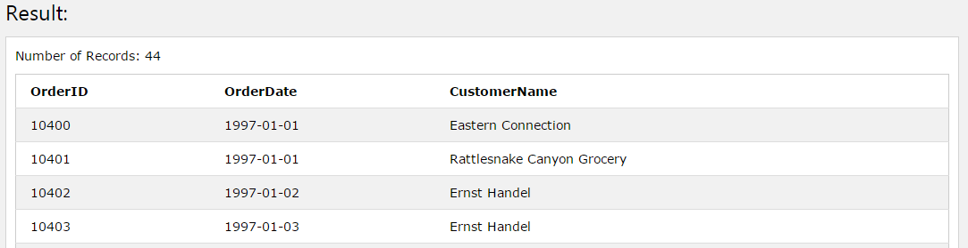

SELECT ord.OrderID, ord.OrderDate, cus.CustomerName

from Customers cus,

Orders ord

where cus.CustomerID = ord.CustomerID

and OrderDate > '1996-12-31';

6. Display each Order and Product ID sold as well as the total sales for each product (sales = productprice*quantity). Hint: You will have to join the Products table to get the price of each product. Your result should look as follows…

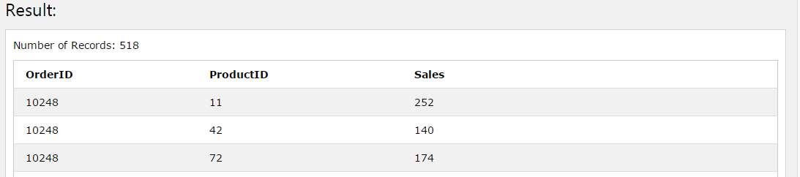

SELECT odtl.OrderID, prd.ProductID, (prd.price * odtl.Quantity) Sales

FROM OrderDetails odtl,

Products prd

where odtl.ProductID = prd.ProductID;

7. Edit your previous query to display the Total Sales for each order. Note that orders may contain multiple products sold however we want to display the sum of all the sales for each order. Your result should look as follows…

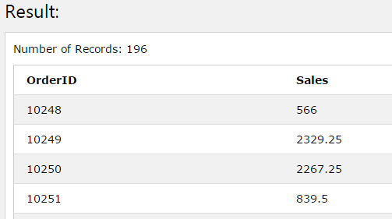

SELECT odtl.OrderID, SUM((prd.price * odtl.Quantity)) Sales

FROM OrderDetails odtl,

Products prd

where odtl.ProductID = prd.ProductID

Group by odtl.OrderID;

8. Edit your previous query to display all Order ID's as well as their Total Sales where the Total Sales for the whole order is greater than 10000.

Select *

From

(SELECT odtl.OrderID, SUM((prd.price * odtl.Quantity)) Sales

FROM OrderDetails odtl,

Products prd

where odtl.ProductID = prd.ProductID

Group by odtl.OrderID

)

where Sales > '10000';

9. Select all order IDs that sold Products with IDs 19 and 35 on the same order i.e. for each order listed, it needs to contain product ID 19 and product ID 35. N.B we’re just looking for the OrderID to be returned. HINT: You can use a sub-query within your query.

SELECT odtl.OrderID

FROM Products prd,

OrderDetails odtl

where odtl.ProductID = prd.ProductID

and odtl.ProductID in ('19', '35');

10. Write a query to list all Employees as well as how many orders they have sold even if they have not made any orders and order the result by number of orders. Your list should like the below diagram…

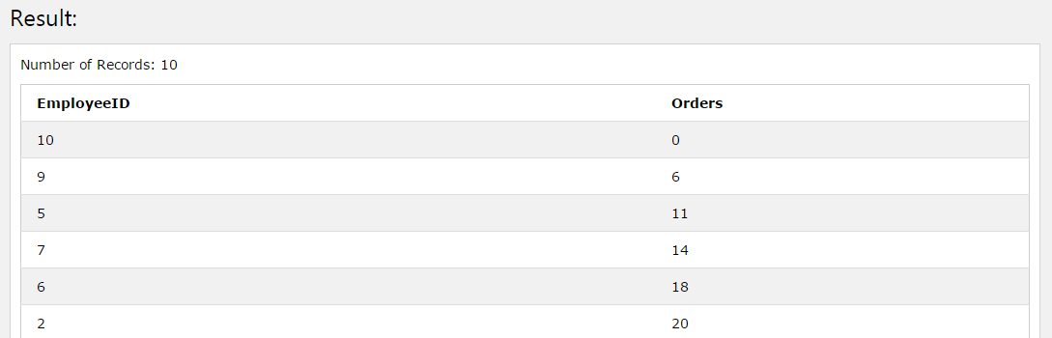

SELECT emp.EmployeeID,

(select count(*)

FROM Orders ord

where EmployeeID = emp.EmployeeID) Orders

from Employees emp

Order by Orders

;